

Wireframe Document

Heart Disease Analysis

We have performed Exploratory Data Analysis using Jupyter notebook and Power Bi Desktop . The following important results came out after detailed analysis .

1. **Number of female heart patient vs male heart patient .**

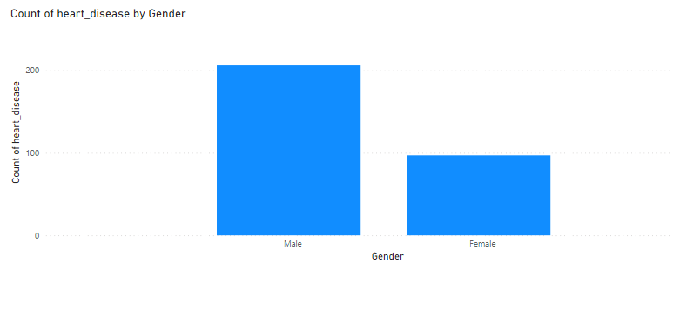

From this findings we came to know that the probability of heart diseases are seen to be high in men than woman .

1. **Average of max_heart_rate by age and heart disease.**

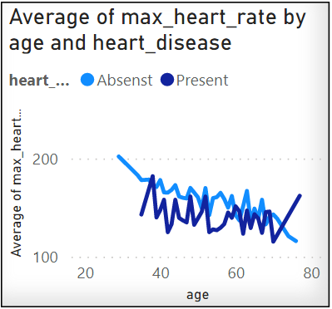

This line graph shows people having lower max_heart_rate have a greater risk of heart diseases.

1. **Count of heart disease by age**

This graph shows heart disease happens to most of the people having flat at the age of 50-60 .

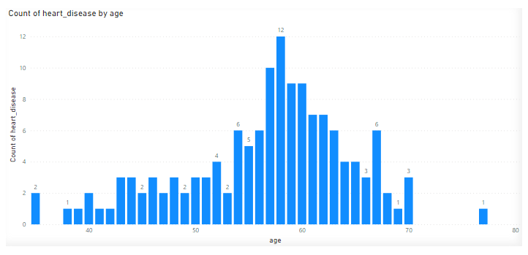

1. **Count of heart disease by pain type**

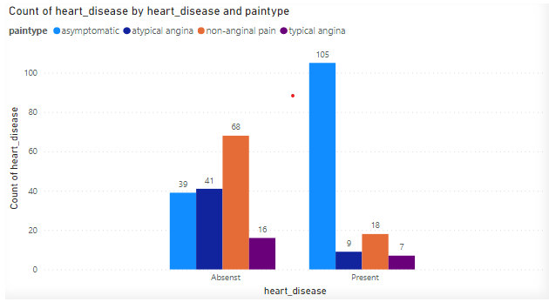

This bar plot shows that 80% of the heart disease are asymptomatic in nature . So we need to be a precaution and without any symptoms also need to do heart check up at least once in a month .

1. **Average cholesterol, max_heart_rate and blood pressure by heart disease.**

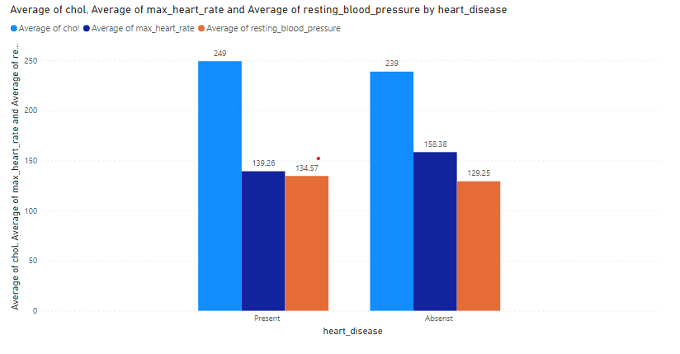

Again this bar plot shows people having lower max_heart_rate have greater risk of heart disease and having more than 130 mmHg blood pressure at age 42 have also high risk of heart disease .

1. **Count of heart disease by age and ST slope**

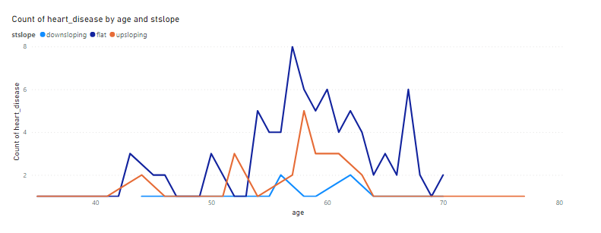

The line graph slows people having ST slope high are having a greater risk of heart disease .